Journal Entries Bot

## Instructions

Instructions for “Journal Entries Bot”

**Please read and follow all the instructions for a proper use of application!**

## Pre-requisites:

**Part 1. Pre-requisites (JE formats and maximum rows admitted):**

Journal Entries app working with the following JE file formats:

1. CSS format (Cont/Suma DR /Suma CR)

|  |  |  |
| --- | --- | --- |
| **Header name** | **Format** | **Example** |
| Account | General / Text | “101100” |
| Amount Debit | General / Number | **39,000** |
| Amount Credit | General / Number | **39,000** |

1. **CCS format (Cont DR /Cont CR /Suma)**

|  |  |  |
| --- | --- | --- |
| **Header name** | **Format** | **Example** |
| Account Debit | General / Text | “101100” |
| Account Credit | General / Text | “101100” |
| Amount | General / Number | **39,000** |

1. **CCSS format (Cont DR /Cont CR /Suma DR /Suma CR)**

|  |  |  |
| --- | --- | --- |
| **Header name** | **Format** | **Example** |
| Account Debit | General / Text | “101100” |
| Account Credit | General / Text | “101100” |
| Amount Debit | General / Number | **39,000** |
| Amount Credit | General / Number | **39,000** |

* **Please notice that the maximum rows admitted in one file for JE will be 600K and always in xlsx format.**

**Part 2. Import files:**

User should import the following databases into their corresponding button.

* Current year Trial Balance file with the following header:

|  |  |  |
| --- | --- | --- |
| **Header name** | **Format** | **Example** |
| Account | General / Text | “101100” |
| Description | General / Text | “CAPITAL SOCIAL SUBSCRIS NEVARSAT” |
| OB | General / Number | **39,000** |
| DM | General / Number | **0** |
| CM | General / Number | **0** |
| CB | General/Number | **39,000** |

* - Journal Entries file with the following header:

1. **CCSS(format)**

|  |  |  |
| --- | --- | --- |
| **Header name** | **Format** | **Example** |
| Account Debit | General / Number | “101100” |
| Account Credit | General / Number | “101100” |
| Description | General / Text | “CAPITAL SOCIAL SUBSCRIS NEVARSAT” |
| JE Number | General / Number | “310” |
| Date | Date | “31/12/2020” |
| Amount Debit | General / Number | **39,000** |
| Amount Credit | General / Number | **39,000** |

1. **CSS(format)**

|  |  |  |
| --- | --- | --- |
| **Header name** | **Format** | **Example** |
| Account | General / Number | “101100” |
| Description | General / Text | “CAPITAL SOCIAL SUBSCRIS NEVARSAT” |
| JE Number | General / Number | “310” |
| Date | Date | “31/12/2020” |
| Amount Debit | General / Number | **39,000** |
| Amount Credit | General / Number | **39,000** |

1. **CCS(format)**

|  |  |  |
| --- | --- | --- |
| **Header name** | **Format** | **Example** |
| Account Debit | General / Number | “101100” |
| Account Credit | General / Number | “101100” |
| Description | General / Text | “CAPITAL SOCIAL SUBSCRIS NEVARSAT” |
| JE Number | General / Number | “310” |
| Date | Date | “31/12/2020” |
| Amount Credit | General / Number | **39,000** |

## Instructions:

1. Open the on http://192.168.1.222:2000/:

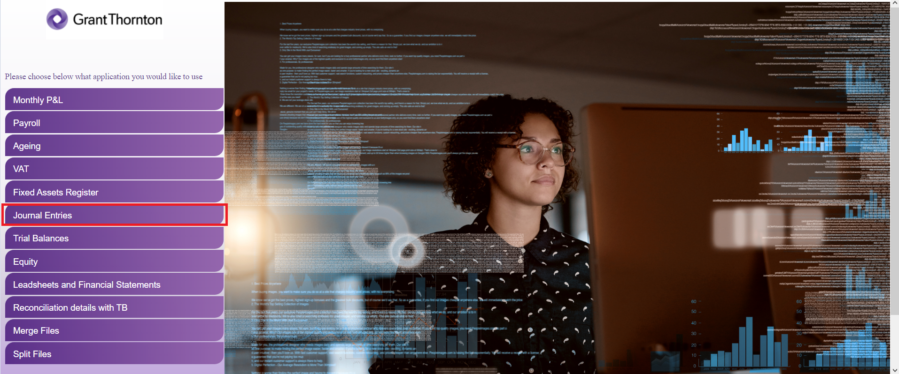

1. Enter the client’s name and the period end (MM/DD/YYYY) of the audit.
2. Click “Import Journal Entries” button and select the JE document.
3. Click “Import Trial Balance” and import the Trial Balance template.
4. Select the desired test which must be performed by app.
5. Insert the company name, year end, preparer name, prepared date, and threshold for account detail extraction.
6. Click “Run”. Once clicking that, the robot will ask the desired saving location, will process your request and exit the application, then announce you if the process succeeded.

For any issues, questions and/ or suggestions, please contact:

Andrei Soare, Andrei.soare@ro.gt.com

Cristian Iordache, [cristian.iordache@ro.gt.com](mailto:cristian.iordache@ro.gt.com)

Bogdan Constantinescu, [bogdan.constantinescu@ro.gt.com](mailto:bogdan.constantinescu@ro.gt.com)